**Maintaining File Consistency in Your Gnutella-Style P2P System**

**Output File**

**CS-550 Advanced Operating Systems**

**Name: Suraj Kumar Didwania (A20334147)**

**Name: Lawrence Amadi (A20382063)**

**Project Title: Maintaining File Consistency in Your Gnutella-Style P2P System**

**OUTPUT FILE:**

**Step-by-Step Execution:**

**Peer end:**

**A) Opening the command prompt and getting into the folder of build.xml (Ant file)**

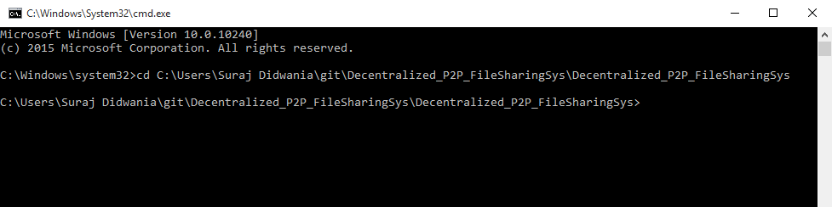

**B) Running the ant file using below command.**

Ant -buildfile rmibuild.xml



The above command will start the rmiregistry for 10 peers with rmic for peerserver and peerclient.

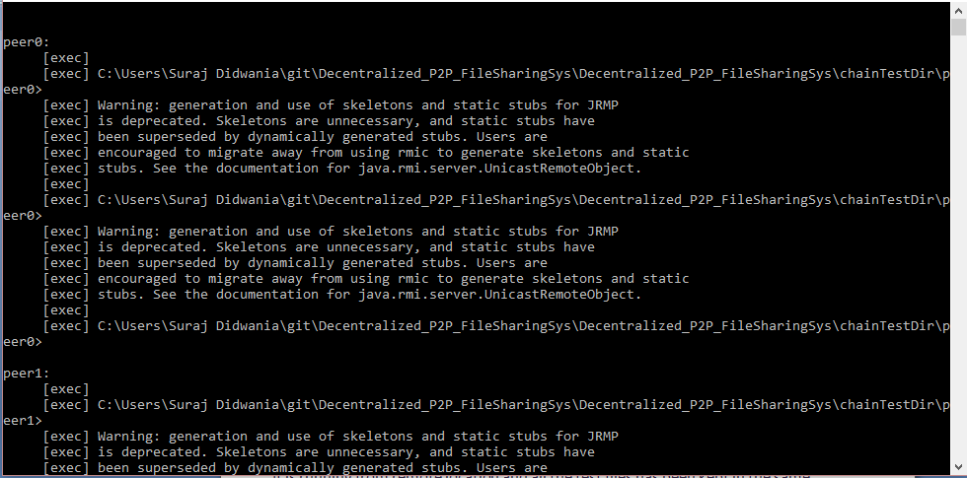

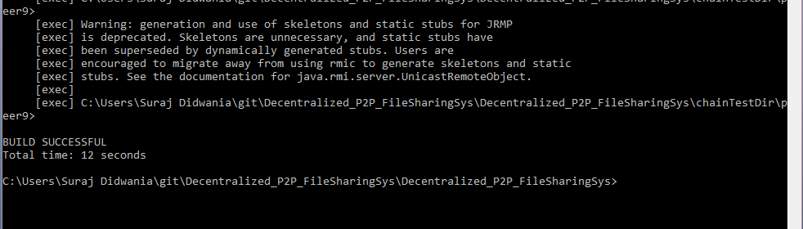

All the registery will be opened and minimise automatically. The next step is just to execute the another ant file to run the linear topology.

C) Run the below ant command to run the java program using below command

Ant -buildfile build_Linear.xml



10 Command prompt with be opened with the exact information and user console.

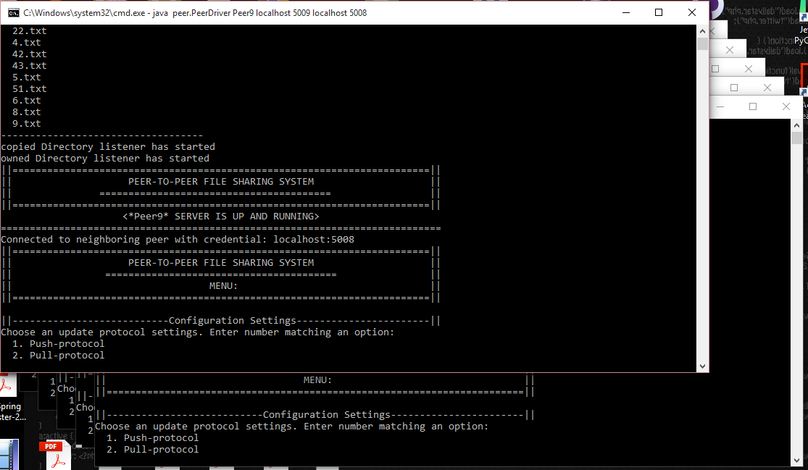

All are set. We are ready to execute the commands and download file from one peer to another peer in distributed way.

Each peer has the UI as given below:

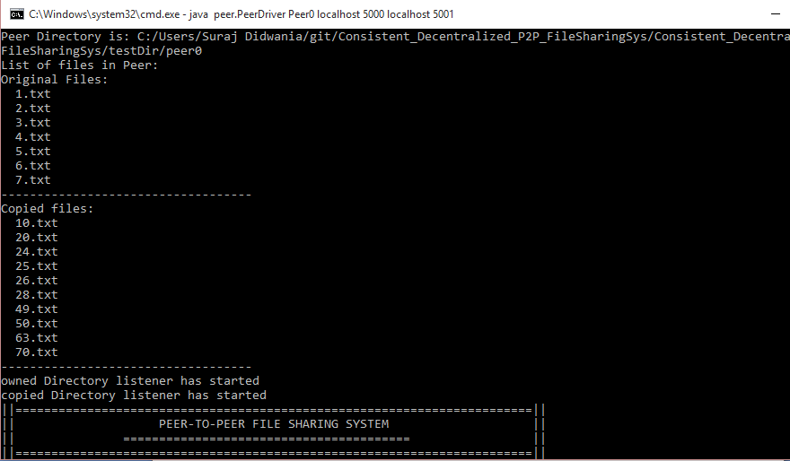 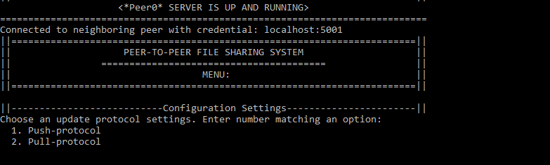

The screen shows the Peer name, IP Address, port number and neighbour IP address and port number.

If pressed 1: Push Protocol

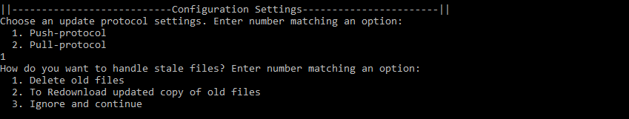

If Pressed 3: Ignore and Continue

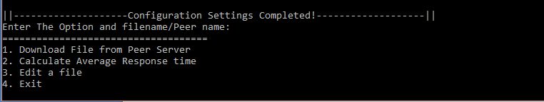

If pressed 1 filename i.e. 1 18.txt

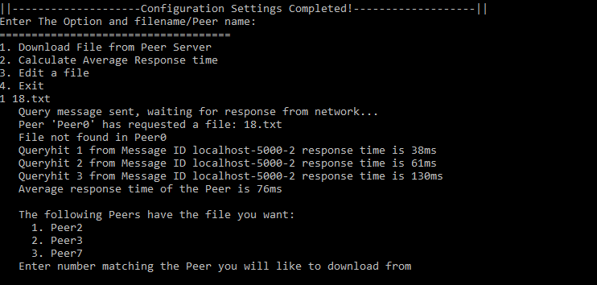

If pressed 1

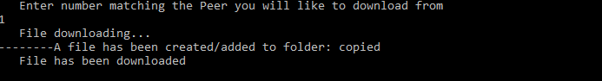

Peer2 UI.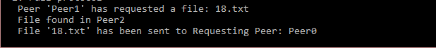

I pressed 3 in order to edit the file

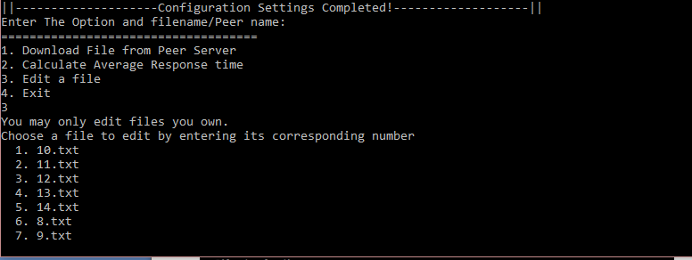

Now pressed 1 to edit file 10.txt



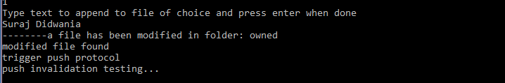

Whereas, the message where this file exist in the copied directory

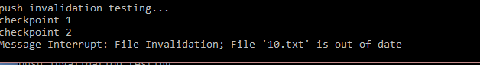

Next step,

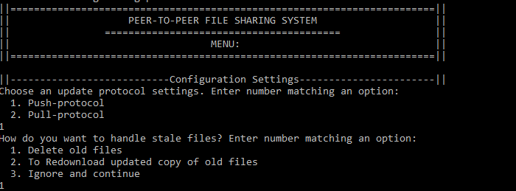

Pressing 1 to delete old files

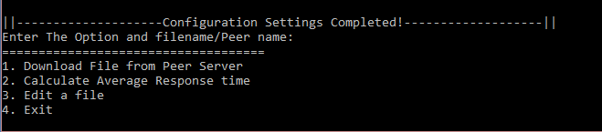

While performing Editing of file

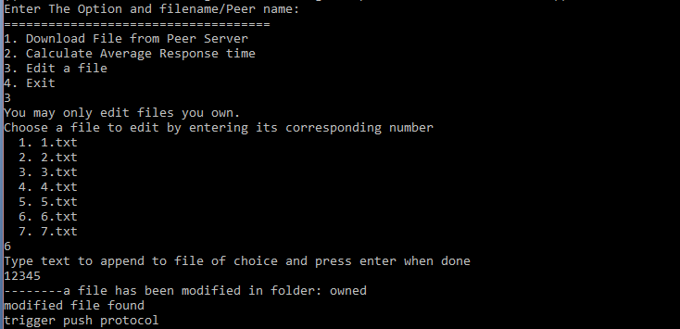

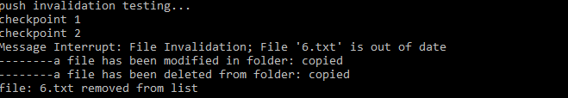

Next Step, if pressed 2: pull protocol



